 | 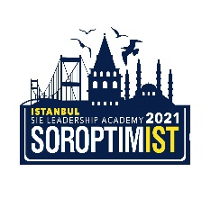

SOROPTIMIST INTERNATIONAL OF EUROPE
VIRTUAL LEADERSHIP ACADEMY
JULY 5, 2021 – JULY 10, 2021 SI TURKEY
APPLICATION FORM FOR PARTICIPANTS
*Applicants are required to fill in this form and submit it online to the relevant Soroptimist Club. Please leave no blank fields.
Personal Data
Name in full: (Last name, First name)
Date of birth:
Place of residence (Country):

PRESENT STATUS
STUDENT:
FACULTY /DEPARTMENT /GRADE:
Undergraduate / Postgraduate / Doctorate

EMPLOYED:
Educational background:
Occupation:
Telephone/Mobile: E-mail:

SOROPTIMIST UNION / CLUB CONNECTION
ARE YOU A SOROPTIMIST OR A SOROPTIMIST SCHOLARSHIP HOLDER?

A-) NAME OF UNION /CLUB:
B-) NAME OF SINGLE CLUB:
C-) NAME OF GRANTER CLUB:
IF NOT PLEASE INDICATE YOUR REFERENCE
NAME OF UNION /CLUB / SINGLE CLUB:
Please briefly indicate the reason(s) why you are interested in attending the LA? (Max.50 words)

